Interdisciplinary course of

**Design and Robotics**

5° edition, 2017

Professors:

Andrea Bonarini, DEIB department, Politecnico di Milano

Maximiliano Romero , DPAC department, Università IUAV, Venezia

Tutors:

Andrea Brivio, Yael Bendit,

Students:

Moreno Sardella, school of Computer Science and Engineering

Dimitar Anastasovski, school of Computer Science and Engineering

Lorenzo Vignati, school of Biomedical Engineering

Paolo Ritter, school of Biomedical Engineering

Luca Fochetta, school of Computer Science and Engineering

# Index

Index 2

Abstract 3

Description 3

Research 4

State of the Art 4

Inspiration 5

Representation 5

Development 6

Interaction 6

Shape 7

Mechanics 7

Electronics 7

Informatics 8

Conclusion 8

Bibliography 8

Annex 9

Interaction 9

Shape 9

Mechanics 10

Electronics 10

Informatics 11

# Abstract

Our work consists in the projection and construction of a first prototype for a robot, whose goal will be to attract people and make their curiosity drive them into a certain restaurant.

We chose to advertise a fish restaurant, but most probably not a sophisticated one, in fact our robot will be an attraction more for kids than for adults. The base idea is to have more than one robot, shaped as little hermit crabs that will run on a platform with the menu of the restaurant, and will emit acute sounds and light to attract attention.

The presence of sensors will make them act as they are scared when people approaches the menu, at which point a bigger hermit crab will start to interact with the person.

This first prototype is a single robot, way bigger than the final product, because of the difficulties encountered in the miniaturization, and without any form of interaction.

The final result was a robot with a nice hermit crab shell made of a polymeric spongy material, that could move in circles and on 8-shaped trajectories, while lifting its shell up and down as if the little inhabitant inside was peeping out from his home.

In the second version of the robot we managed to reduce the dimensions of the base to values suitable for being put on a restaurant menu without becoming an obstacle for who tries to read. This could be achieved thanks to smaller components bought expressly for this scope and also to the possibility to use an FDM 3D printer to create a custom base.

The other main change is the presence of many sensors that allow the combination of different movements with the ability to avoid obstacles and stay inside a precise area without trespassing a black peripheral line.

# Description

The purpose of the project is to build an autonomous robot able to interact with people in order to promote a restaurant. Our idea is to build multiple robots with the appearance of hermit crabs that will be able to understand when a person is approaching them and go hide (under their shells). Then they will start slowly to come out from the shell and start to do some movements and attract attention with sound and light. For the first prototype, we built an hermit crab able to move around and lift his shell without any remote control or external alimentation. The second one was capable of moving randomly and, exploiting his sensors, avoiding obstacles and dark regions of the floor.

Our concept is a family the hermit crab-like robots of which two will be very small, but also very active, being able to move around, while the third one will be bigger and will not have wheels, but will feature the abilities to shoot soap bubbles, detect the presence of possible customers and emit more complex sounds.

Through infrared communication between the mother hermit crab and the two little ones, these two will also be alerted of the presence of customers and react escaping and showing fear, while the big one will interact speaking to the people.

# Research

## State of the Art

The state of the art are two different projects, both much different from ours, but still for some aspects similar.

The first one is made by Cepia and is called Xia Xia. It is made for kids and the main attraction are the four little hermit crabs with interchangeable shells that can move around autonomously (but without sensors and steering mechanisms they can only move straight forward and backward). What we take from this project is the presence multiple little robots, but what will distinguish our work is the presence of many sensors and a much more complicated algorithm that will allow real interaction with both the other crabs and the people.

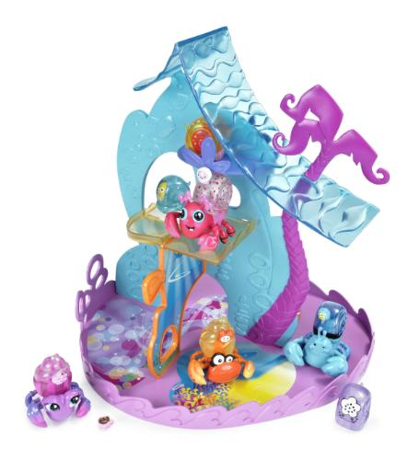

Figura https://www.youtube.com/watch?v=46KlwGfh8VM

The second project is a more complicated robot, that like ours can go around without getting stuck into obstacles, but lacks the aesthetic side and the functions that will allow our robot to interact not only with the environment, but also with people.

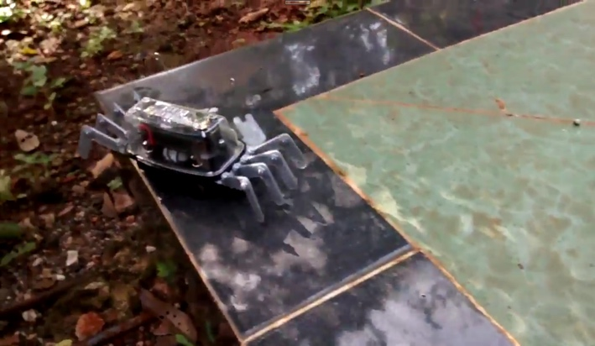

Figura https://www.youtube.com/watch?v=gbPtuy5Ew8Y

## Inspiration

The inspiration arrived from an interesting project made by Japanese artist, Aki Inomata. She 3D printed shells shaped externally as landscapes of important cities (like New York for example) and internally as a natural shelter for the crabs (after studying the structure with micro CT scans). The maim of her project was to stress the relationship between an inhabitant and his home. As the hermit crabs growing change their shells so pieces of land pass from one nation to one another, sometimes even peacefully.

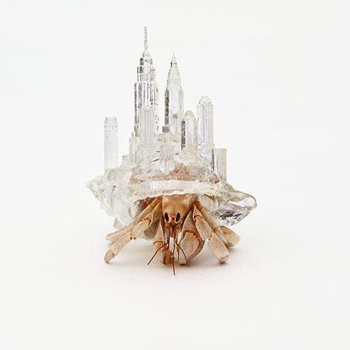

Figura 3 3D printed transparent shell by artist Aki Inomata

## Representation

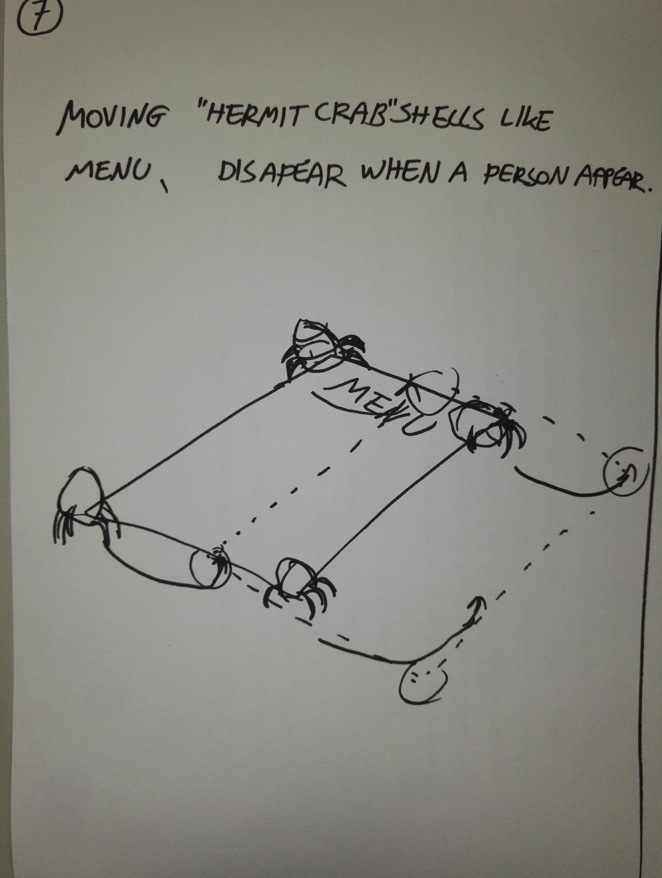

Figura 4 Preliminary sketch of the two crabs on the menu.

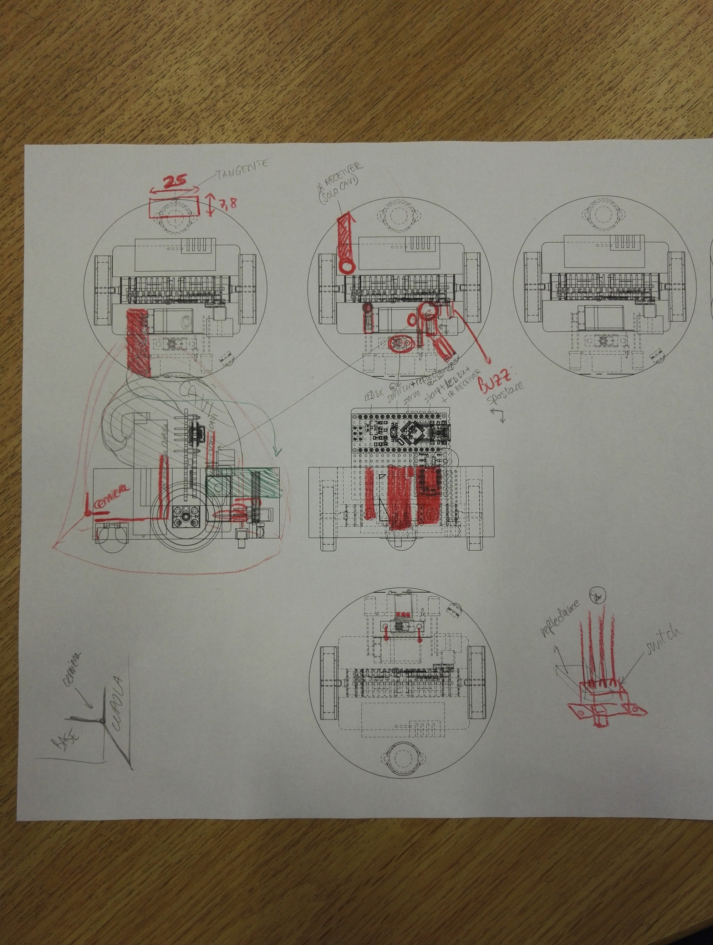

Figura 5 Sketch based on the projections from the cad modeling.  
This helped us with the disposing of components and cables.

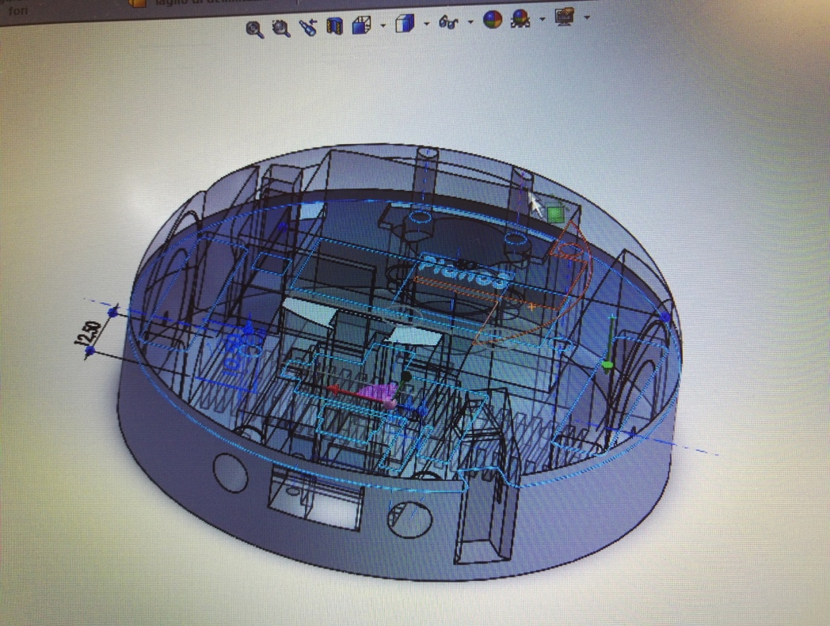

Figura 6 image taken from the processing of the 3D cad model.

# Development

## Interaction

* First prototype:

For the first prototype our attention was focused on the creation of a robot that besides being able to show his main functions, could give a first demonstration of how small we want it to be. For this reason, most of our effort was spent fitting all the needed components in a relatively small ‘shell’ in the most efficient way and making it so it could work without external sources of power.

* Second prototype:

In the second version, although being again much focused on the miniaturization of the robot, we had enough time to implement interaction with the surrounding environment.

We installed on the front side of the robot a proximity sensor to detect obstacles on his path and make it avoid collisions. This function will help mostly crashes between the two robots, since the containment of the movements inside a precise area is achieved thanks to a reflectance sensor installed in the inferior part of the base; this sensor will be used to detect a black line that will be placed around the perimeter and the robot will use this information to turn round and continue moving in the area where it is allowed to stay.

## Shape

* First prototype:

The shape of the robot is the one of a hermit crab, with a big conic shell. It was made with two wheels at base in order to make it move.

* Second prototype:

The shape of the prototype reminded mainly the same of the first prototype, but in the second version we managed to reduce further the diameter of the base and the dimension of the whole structure, since we were able to find very tiny components and use the FDM technique to 3D-print the base and mechanical support for the robot. We made our best to be precise in every step of our work, since we want to use this second prototype as one of the two definitive little robots needed for our project.

## Mechanics

* First prototype:

The first prototype was built using a circular rigid plastic base we cut from a sheet on top of which we disposed the batteries, the motors (making the wheels pass through the base) and on top of them the servo motor with its shaft. On the back of the base we put a hinge to make possible the rotation of the shell around a fixed axis allowing the opening from the front due to the “popping up” of the shell itself.

* Second prototype:

The mechanical part of the robot is mainly the same seen in the first prototype, although the components were all exchanged with smaller versions.

The main difference is that the base was now thought in order to be a 3D printed solid volume in which we could fit the components thanks to proper housings.

## Electronics

* First prototype:

We used Sparkfun Dual Tb6612FNG as motor driver to control two DC motors. As microcontroller we used an Arduino Nano Atmega AT320p to which we connected the driver and the servomotor. The robot is power supplied trough two alcaline battery at 9 volts.

* Second prototype:

The main difficulty for the electronics was to use small sensors (the biggest one is approximatively 10 mm x 20 mm) able to perceive an obstacle in front of the Hermit Crab or the different colour under the robot. In addition, we have two micro motors controlled trough a motor driver able both to supply and control them by using three pins for each motor. Also a servo is connected directly to the board and it will be used to pull up and down the shell of our robot. Two pins are used for two IR Receivers that will have to receive some commands coming from a bigger hermit crab. As microcontroller, in order to keep small the robot, we used an arduino nano. We use a 7.4V Li-ion battery in order to supply all the components. Two small LEDs are used as “eyes” of the Hermit Crab and they are connected directly to a digital pin.

BILL OF MATERIAL in the annexes

## Informatics

* First prototype:

We used the library servo.h to control the servomotor whose job is to lift up and down the shell of the hermit crab. The problem we faced was of mechanical origin: the self-made wheels could not be perfectly symmetric, but we managed to solve it by making one motor go slower than the other one.

* Second prototype:

We used three pin to control the rotation of each motor where two pins are used for direction and one for the speed (PWM pin). In order to easily integrate the movement in our code, we create different functions for each kind of movement (go forward, backward, turn, spin). These functions are called randomly from a “mother function” so that the movement cannot be predictable. We used a function for a digital proximity sensor that tell us if an object is closer than ten centimetres from the head of the Hermit Crab. Another function is used for a reflective sensor put under the robot used to see the colour of the table. The function return BLACK if the value is over a certain threshold, WHITE otherwise.

# Conclusion

We learnt about the difficulty of using a small case without having problems arranging the huge mass of cables and all the mechanical parts and about the big amount of energy and power needed by a system like this, which must never be underestimated.

With the second prototype we understood how difficult is to try to realise something that should be the final version of the robot at just the second attempt. This led us to dedicate too much time to resolving problems given by the miniaturization and the assembly and we didn’t focus enough on the interactive aspect.

# Bibliography

<http://www.aki-inomata.com/works/hermit/>

<https://www.youtube.com/watch?v=46KlwGfh8VM>

<https://www.youtube.com/watch?v=gbPtuy5Ew8Y>

<https://www.arduino.cc/en/Tutorial/HomePage>

<https://www.arduino.cc/en/Guide/ArduinoNano>

# Annex

## Interaction

Flowchart of interaction

## Shape

|  |  |
| --- | --- |
| Figura 7 mechanical backend of the first prototype. | Figura 8 first version of the shell. |

3D model of the second prototype: <https://drive.google.com/open?id=0B51cJQYbwQ2adlE5M1NEWlhTNkE>

## Mechanics

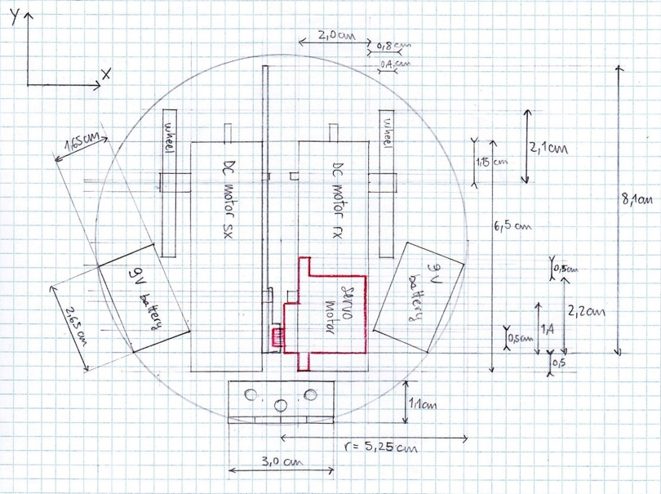

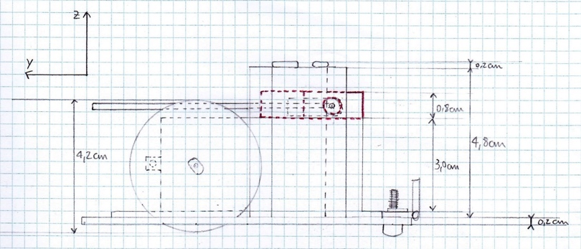

## Electronics

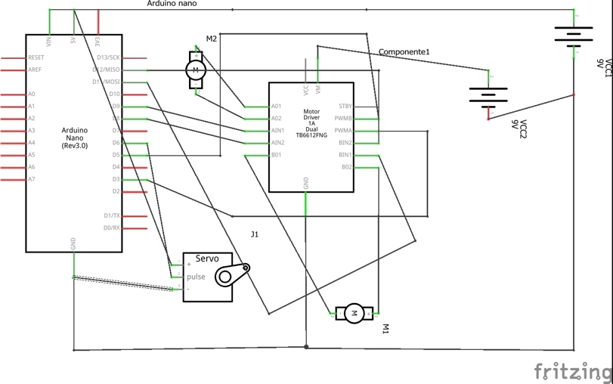  
Figura 11 first prototype

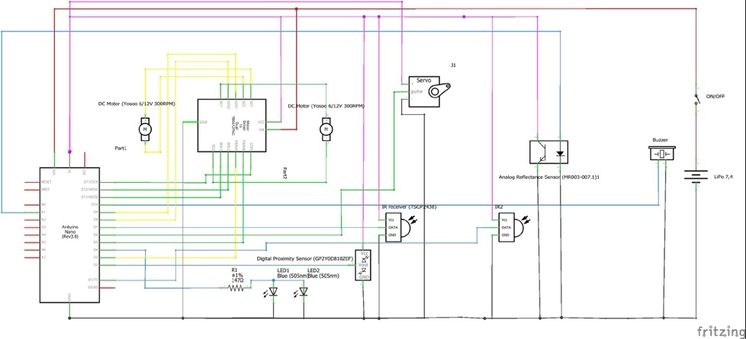  
Figura 12 second prototype

## Informatics

Code: <https://drive.google.com/open?id=0B51cJQYbwQ2aNlA0TE5vcHZDeUU>